How to create an XDC from Vivado

Created by: David Rubio G.
Blog: https://soceame.wordpress.com/
GitHub: https://github.com/DRubioG
Last modification date: 09/03/25

In previous posts I explained how to make an XDC by hand, now I'll explain how you can create your own from Vivado.
The first thing you have to do is implement it. With the implementation done, open the profile and in the upper tab of Window an option called I/O Ports appears.
In this tab you have to follow what the schematic of the board dictates.
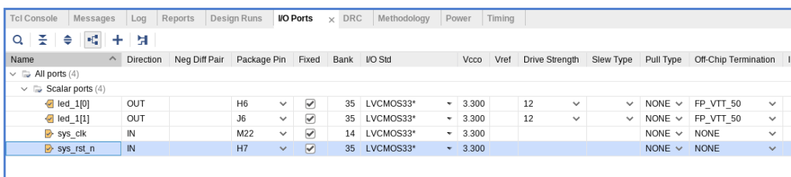
Here you can select the pin you want for the port, and the voltage of the pin, in our case 3.3V.
Once you have the pins created you have to save them.

Then, Vivado will ask you if you want to create a new one, or overwrite an XDC you already have.

Create a clock
To create a clock and just like in the previous step, in Tools, an option called Timing Constraints Wizard appears.
When you click on it, a tab opens, to configure the profile you want.
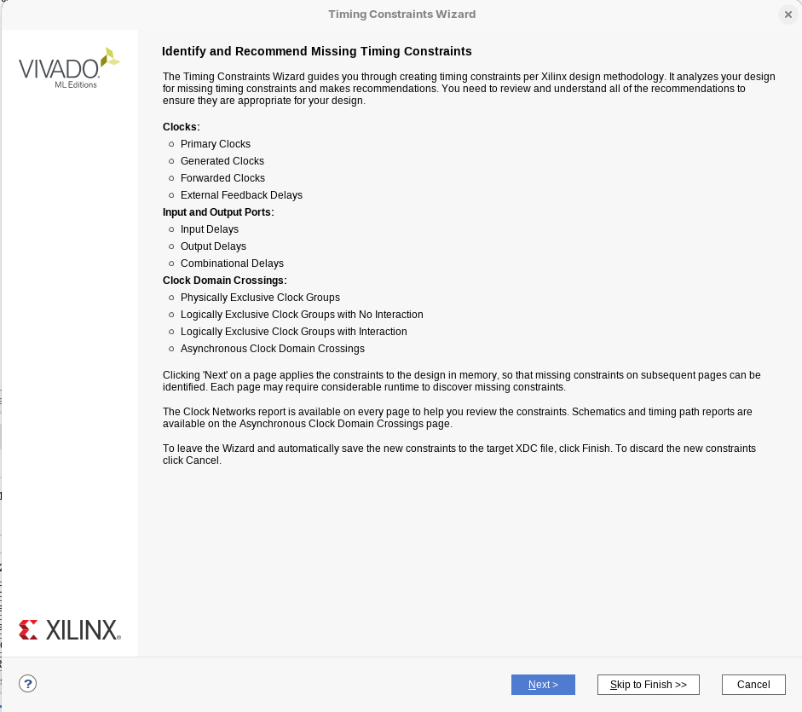
In this tab you choose the primary clocks you want
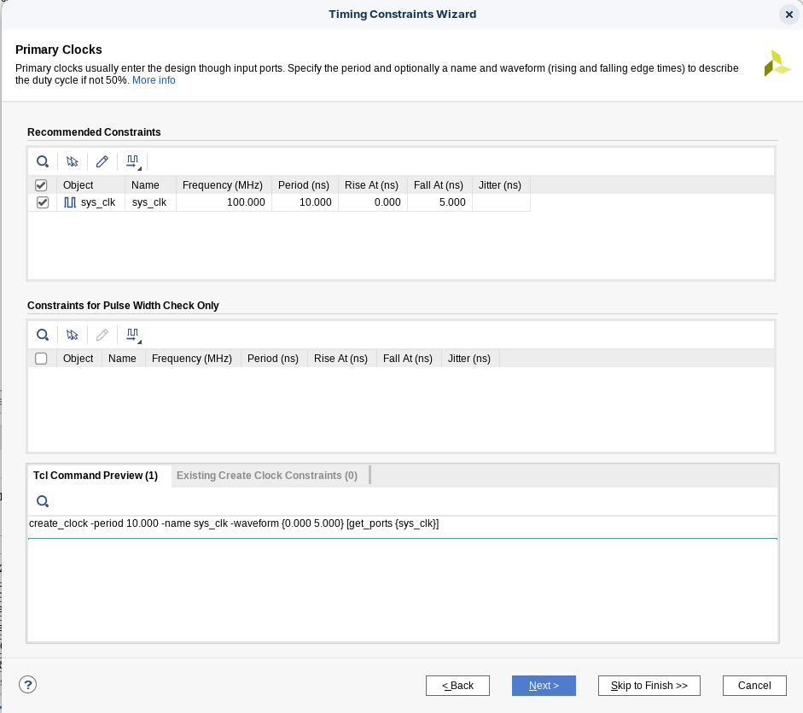
It also allows you to add delays to the clock, although it is not necessary to give it delays.
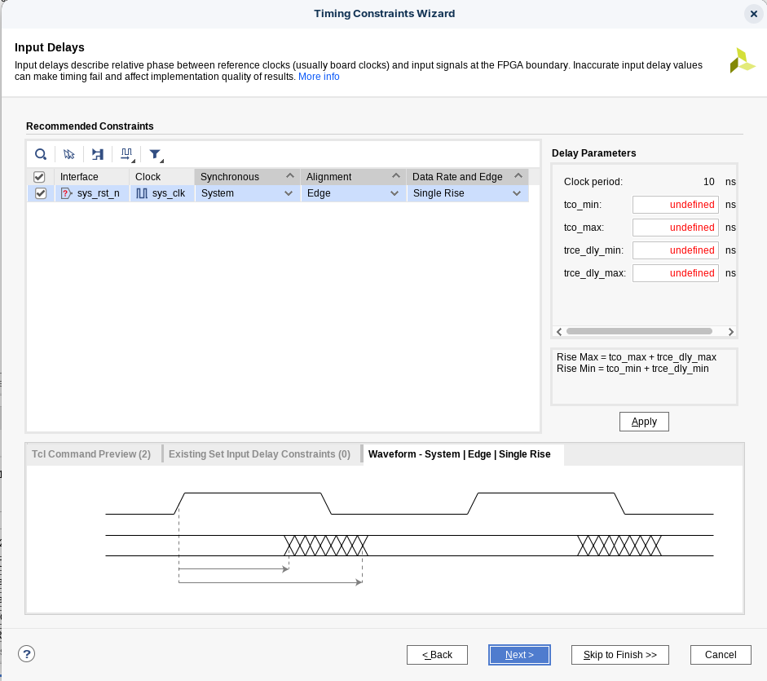
Once done in Timing Constraints the created clock will appear
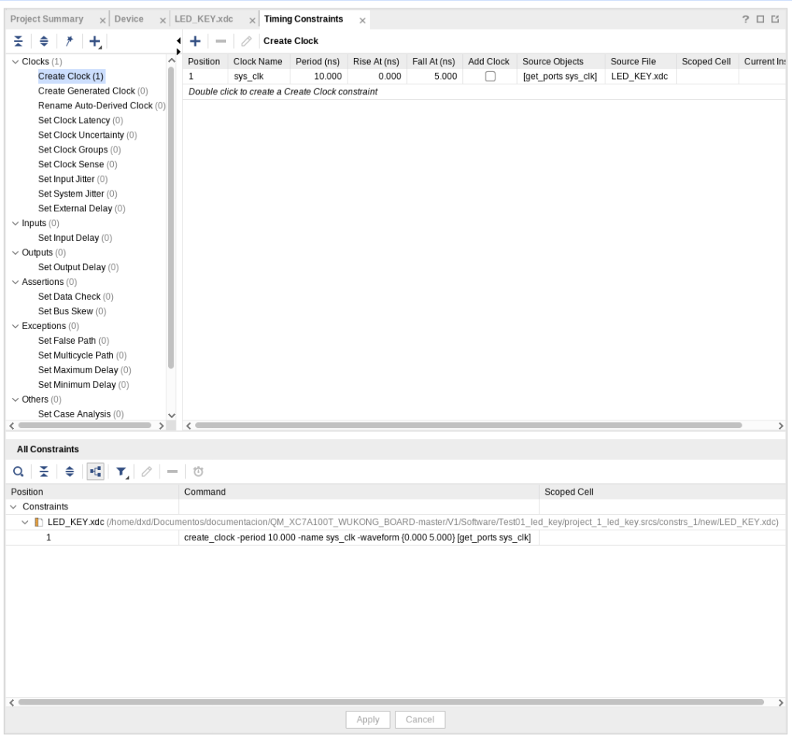
And in the XDC the clock that has been created will appear

